User Manual for Server:

The server application must be run so that users can connect to play the game. The user who is hosting the game must enter the file name in the field provided in order get the questions for that particular game. It should be noted that more than one files may be uploaded, thereby, merging all the questions in the number of files provided.

The host can permanently block a user or block a user for a specific session. In order to block a user permanently, the host must enter the IP address of the user on a new line in the restricted.txt file. However, to block a user for a specific session, the host can enter the user’s IP address in the text field provided and click the Block User button. Additionally, to block multiple users for a specific session, the previously mentioned process is repeated for the amount of users to be blocked.

After entering the category (categories or file(s)) and blocked users (if any, as this is optional), the host must click Host to start the game. When the server has started and is running successfully, clients can connect to the server via the Client Application.

While the game is being played, the server application keeps track of the users, blocked users and a log of all activities occurring at the server. It shows the number of users connected; showing the IPs of each user, the number of times they have connected to the server to play the game and their respective scores. All blocked users, permanently blocked from connecting to the server and temporarily blocked for a session. The log displays all the activity occurring on the server side, which includes the server status, the number of categories being played and total number of questions, and the Client IP addresses connected, along with the score.

When all questions have been answered by the user or when the use quits the game, the host may either leave the server to run or can click the Disconnect button to close the Server Application.

*The Server Application has been opened and this is the first screen the hosting user sees:*

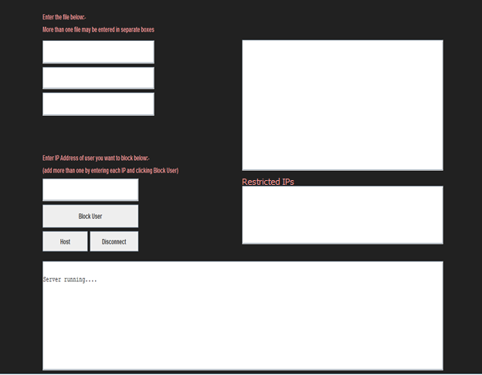

*The “application layer questions” and “network layer questions” files (or categories) have been entered by the host. When the hosting user clicks “Host”, immediately shown are the blocked IP Addresses (in this case, these are the permanently blocked IPs, since the user has not entered any IP addresses to block for this session. Additionally, the server information is shown; indicating the server status, the number of categories being played, and the total number of questions for that session. It should be noted that the text area at the bottom acts like a log for all server-client activity.*

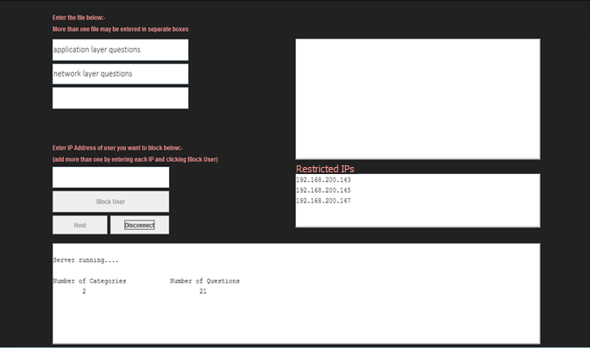

*If the hosting user intends to block a client from connecting to the server for that session, the host must enter the IP address to block and click the “Block User” button before the game is started. To block multiple users for a session, this same process must be repeated. All blocked IPs are shown in the middle text area when the game starts.*

*Single client being blocked:*

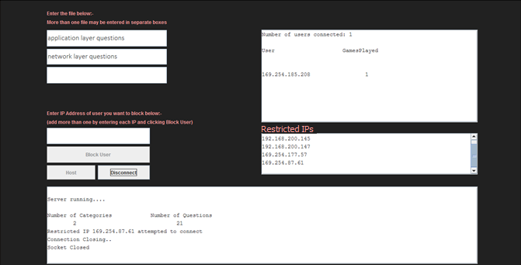

*Multiple clients being blocked:*

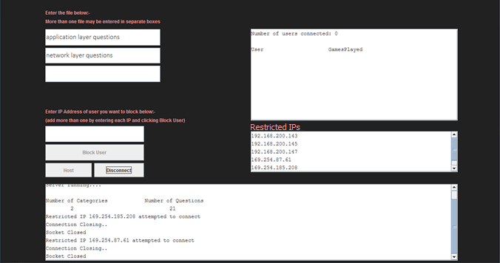

*When a client connects to the server, the text area at the top shows the user connected, the number of times the user has played the game (i.e a user can connect to the same server multiple times). At the bottom, the server log is updated with any activity that has taken place.*

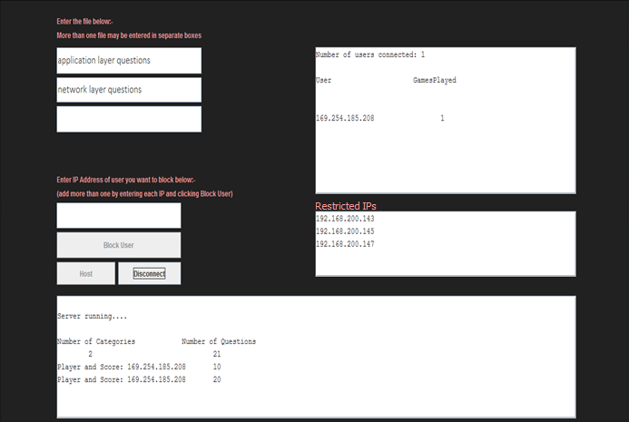

*When multiple clients connect to the server, the text area at the top shows the users connected, the number of times a specific user has played the game (i.e a user can connect to the same server multiple times). At the bottom, the server log is updated with any activity that has taken place.*

